# **Chapter -6**

# **Other project issues:**

## **Limitation:**

There is certain limitation of my system that it cannot perform or cannot function well. Therefore, the limitation of online loan management are as follows:

1. Client and customer cannot have conservation online through chat box.
2. Admin cannot send mails in Gmail as a reminder to the clients to pay their interest.
3. There’s no facility of paying the loan/ interest online.
4. Cannot track the location of the client who took loan from the bank.

## **Future work:**

1. **Chat box**

Here the chat box functionality helps the client to get connected to the admin of the bank where the client can ask the queries that he/she finds difficult understand loan taking criteria. With this function the client can interact with admin anytime. Currently our system lacks this functionality but it will be included in future wok.

1. **Email**

Currently the admin sends the email through mail-trap which is fake kind of email and in future I could like to Gmail services in the system so that the admin can send the client after the loan completion or if the client does not pay interest in time, in that case that reminder of payment can also be send through email. This functionality will be added in future work so that the system can provide its best services.

1. **Online payment**

With the help of this functionality client can pay their loans online. This service will save the time of the client as they don’t have carry cash and go to bank to pay their debts, the transaction can be made online. Here in this context the payment can be made through e-sewa, IME etc. This functionality will be added in future work so that the system can provide its best services.

1. **Tacking location**:

Currently the admin can track the payment only paid the customer but in future I would like to implement this functionality so that it would be secure to know where the person is after taking the loan. This functionality would secure the bank from loan fraud.

## **Risk management:**

* Risk management is risk recognition, assessment and prioritization accompanied by organized and cost-effective use of resources to mitigate, monitor and control the threat or effects of unfortunate events and optimize opportunities realization. No system is perfect in this world, it certainly contains some defects. The system might get infected or may get harm. It may be affected by the natural disaster, employee theft, system failure, human error etc.

Here down below is some of the risk that might affect my project:

1. Data theft: it’s the act of stealing information from an unknowing victim with the intent of getting confidential information. This risk can cause the loss of data/information of customer can sometimes can be used against them. It is done by the system administrators and office workers to get the confidential information of customers.
2. Update/upgrade: When we update the system in to newer version or upgrade the hardware of the system there’s possibility of system failure, crashes which may lead to loss of data completely and there’s chance of not recovering of information.
3. System hardware failure: Many of the files are stored in the hardware in order to get access offline too and if the storage hardware creates problem than it will be difficult to access the data/information.
4. Disaster caused normally: natural disaster is inevitable. It causes a lot of risk. It may cause loss of life. Human disaster can be control but these natural disasters cannot be controlled.
5. Limited resource: it is also one of the types of risk and is neglected the most. People uses inadequate resource’s and tries to finishes the project which may cause problem in the future.

Risk management table:



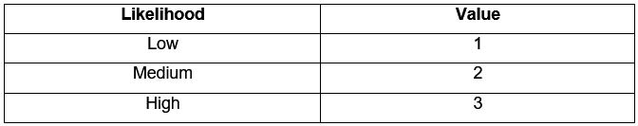

Risk likelihood and values:

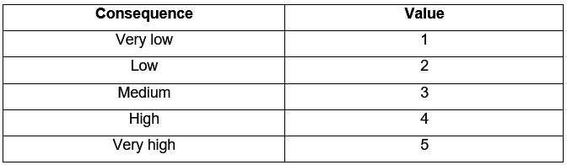

Risk Consequence and Values.

Here down below is some of the risk that will affect my project with their impact and actions:

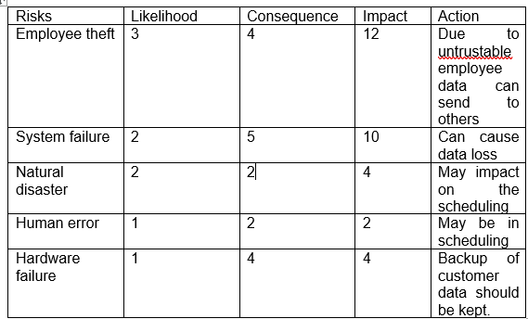

## **Configuration:**

* The management system for software configuration controls basic components such as software objects, program code, test data, test output, design documents and user manuals. It is basically done as it helps in managing the data. Configuration management shows how and where the data/information are store.

For configuration management there is release management which means the process of managing, planning scheduling and controlling a software build through different stages including deployment and testing.

Version control management is known as revision control which manages the changes of documents, computer programs, large website and other information.

For my system I have saved files in the local drive i.e. in the computer and as well as I have pushed my files online i.e. in github.

In drive:

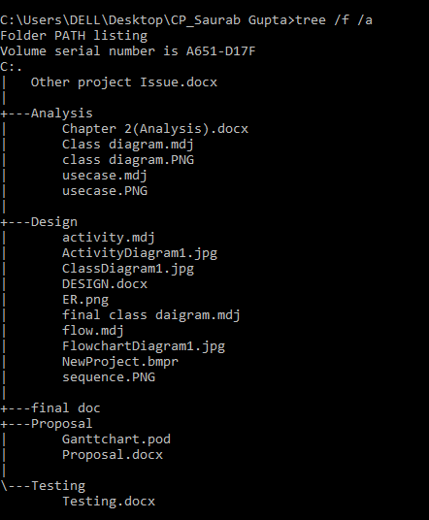

I have also created a GitHub account named saurab906 to store my data within which sub folders are also created. Here down below is the figure that shows how the data of my project are stored in git-hub account.

File saved in github(online):

## **Other project issues:**

**Social factors**: social factor affect the system both in the positive and as well as in negative way. While developing a software social factors should be kept in mind. System should be developed in way that social factors doesn’t get affected.

**Technical factors:** Technical factor is related to the hardware and software specification required by the system to function properly. For my system the basic requirements are that the system needs a minimum of 2 GB of ram to run all the features smooth and sudden. If these criteria do not match then it might affect the software to run smoothly.

**Ethics factors.** Ethics factors are related to the ethics of a people or community. While developing the system the ethics shouldn’t be affected because to make the software popular ethics/ sentimental of the people shouldn’t be hurt.

## **User manual:**

User manual provides the step to use the **Online loan management system,** therefore this manual provides the user guide on how to use the system.

1. **Log in and Registration:**

* Admin can only login in the system and view all the details but in case of user they need to register and login with correct email and password.
* *Login*

Enter correct email and password:

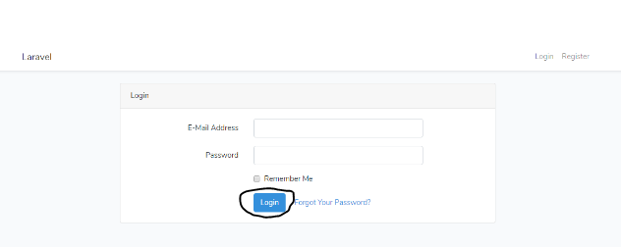

* *Registration page:*

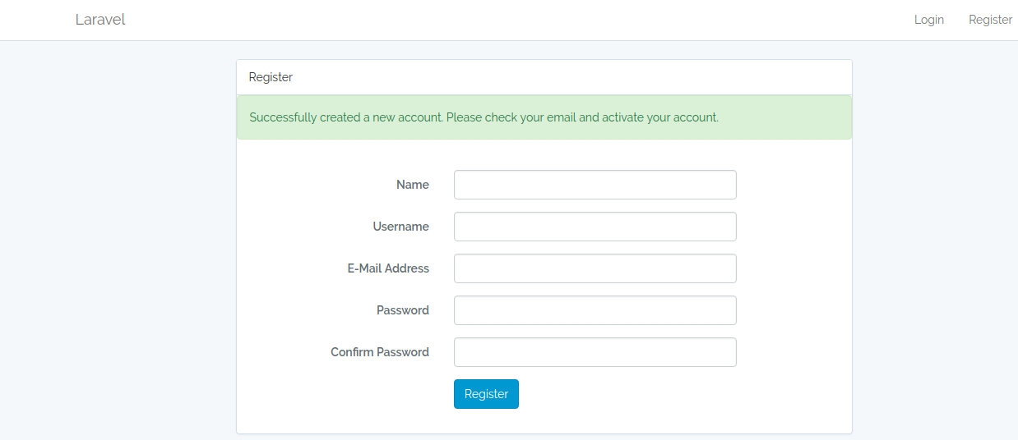

1. Forget password: incase user forgets the password; they can click on it.

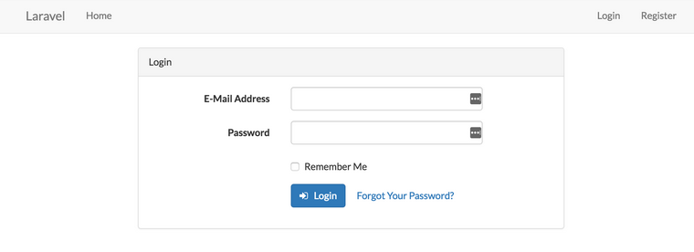

1. After logging in a dashboard open for admin where he can view the details of the client and approve loan and see payment made by them.

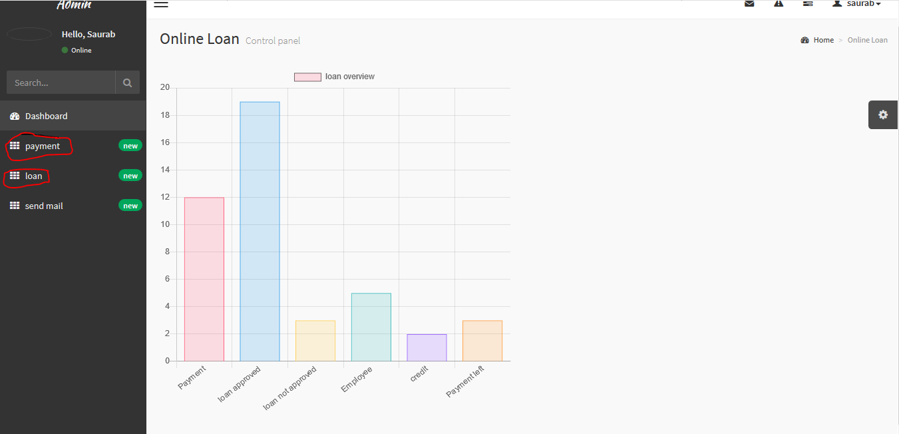

* By clicking on loan admin can view whose loan are approved and whose are not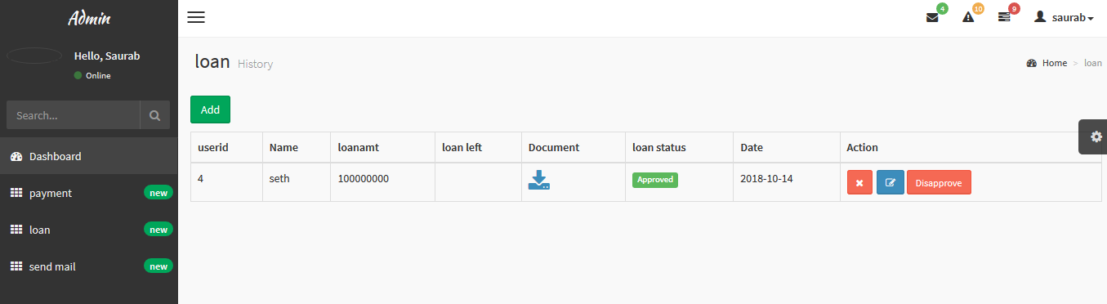
* By clicking on payment admin can view who have made payment.

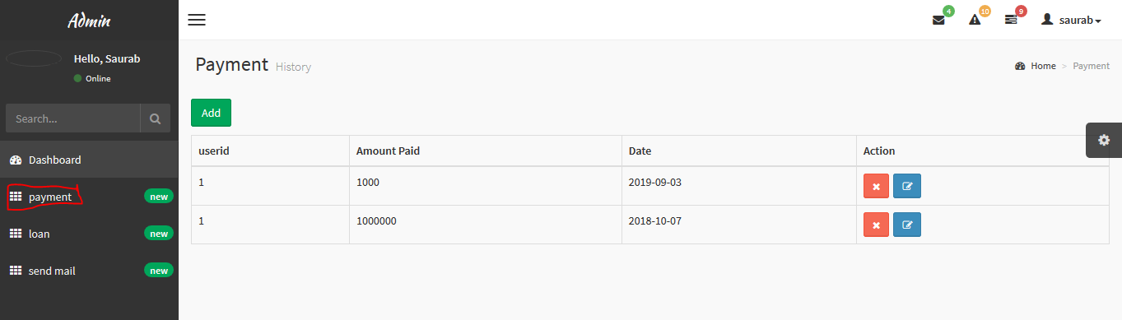

* For client, by clicking on loan they can ask for types of loan and upload their document:

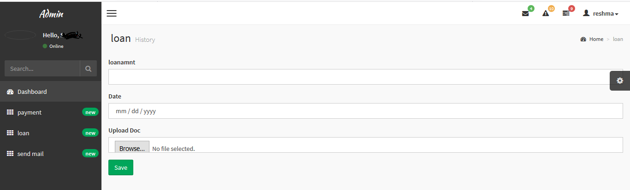

* By clicking in payment, the client can make their payment for the loan that they have taken.

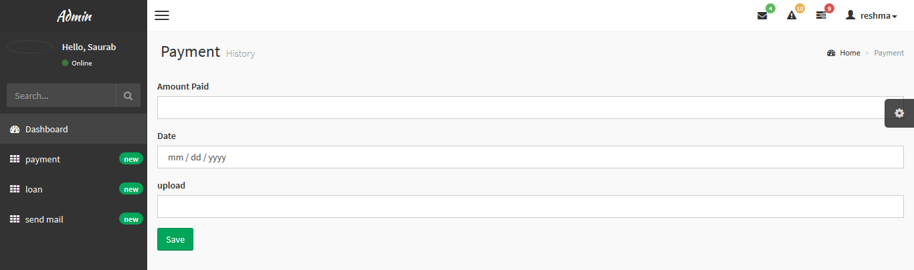

* For updating the data, the client can click on edit button and update their data:

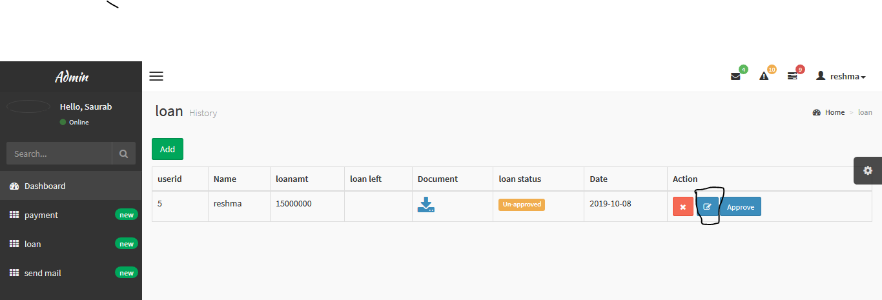

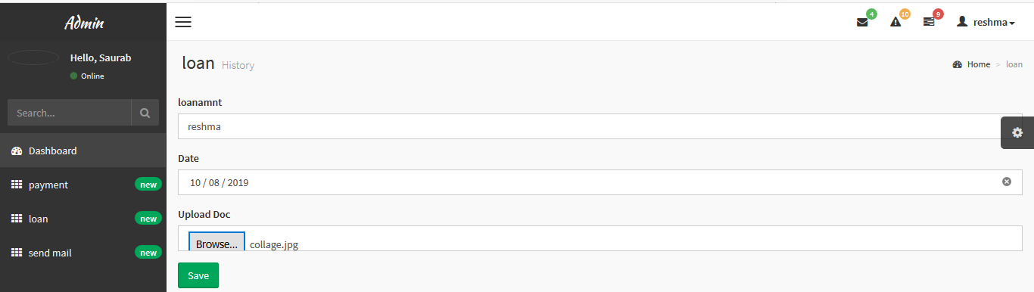

* Only admin can delete the data of the client and for that just click on delete button:

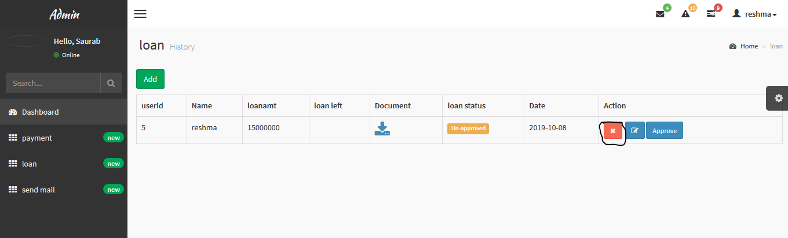

* For signing out they can click on their name on the right-hand side and click on logout:

